**LAMISA QUAIYUM**

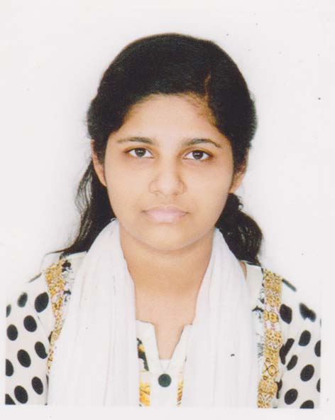

**EDUCATION**

**BSSE Student**

quaiyumshamma@gmail.com

House No: 41/7, Road No: 1 No. Gate, Chand Mia Housing, Mohammadpur, Dhaka-1207

+8801787027488

* Web development
* Software requirements specification.
* Competitive programming.
* Microsoft Office.

**BSSE**

**(Bachelor of Science in Software Engineering)**

3rd Year, 2nd Semester,   
Institute of Information Technology,University of Dhaka

**HSC**

Year-2017,

Result: 5.00 out of 5.00

Group : Science

Hazi Lal Mia City University College, Gopalganj.

**SSC**

Year-2015,

Result: 5.00 out of 5.00

Group : Science

Govt. Binapani Girls’ High School, Gopalganj.

* C & C++
* Java
* Oracle SQL
* PHP
* HTML, CSS, Bootstrap

**KNOWN TECHNOLOGIES**

Working in a progressive environment where I can enhance my skills and learning to contribute to the success of the organization.

**SKILLS**

**CAREER OBJECTIVEE**

**PROJECTS**

* National Girls Programming Contest 2018, DIU.
* **Inter-University Girls’ Programming Contest 2019 Season-2, (NSU**IUGPC**)**

**PARTICIPATION**

* **SPL TEXT EDITOR**

This is a very simple text editor. A basic text editor has some functions like write plain text, save them in a file, copy files, copy lines, paste, create tables ,change font sizes, change font colors, change font types(italic or bold). But it is a very raw text editor project so there is no UI. It shows everything in terminal.

* **Postal Automation System**

Postal Automation System (PAS) will be an automated system for the “Letter-Delivery Department” of Registrar Building, University Of Dhaka. The sole purpose of this department is to send letters to teachers and officials regarding different type of Responsibilities e.g. Question Setter, Script Setter, Member of Exam Committees (Internals and Externals), Exam Question Coordination, Result Finalization.

**PERSONAL DETAILS**

Father’s Name : M. A. Quaiyum

Mother’s Name : Fowzia Khanam

Permanent Address : 196, Udayan Road, Gopalganj Sadar, Gopalganj

Date of Birth : 11 October, 1998

Nationality : Bangladeshi by Birth

Religion : Islam

Blood Group : B +ve

NID No : 4654694829

Listening music, reading books, drawing.

**EXTRA CURRICULAR ACTIVITIES**

**HOBBIES & INTEREST**

Singing & Dancing.

English & Bangla.

**LANGUAGES**